CSA1302-THEORY OF COMPUTATION

Name: V. Sai Krishna
Reg. No. : 192372259

CO2: Design Finite Automata (DFA, NFA, ε-NFA) and Demonstrate Their Equivalence for Recognizing Regular Languages

1. A company is developing a smart security system for a research laboratory. Every employee entering the lab
uses a digital access card that generates a sequence of symbols:
• a → Valid ID scan
• b → Biometric verification
• c → Door access confirmation
The security rule states that:
1. Every valid access sequence must start with a.
2. It may contain any number of biometric checks (b).
3. The sequence must end with c.
Examples of valid sequences: ac, abc, abbc, abbbc

DFA Diagram:
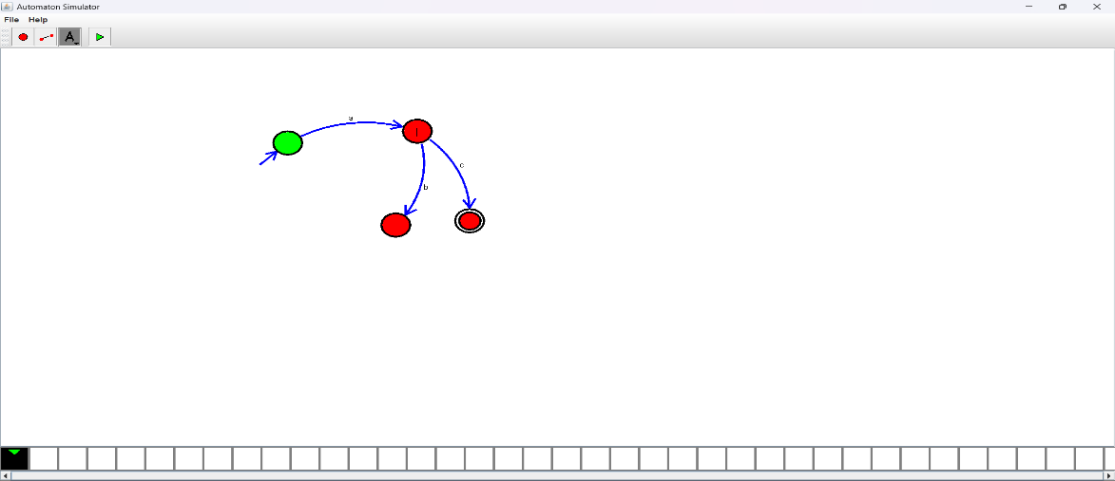
NFA Diagram:
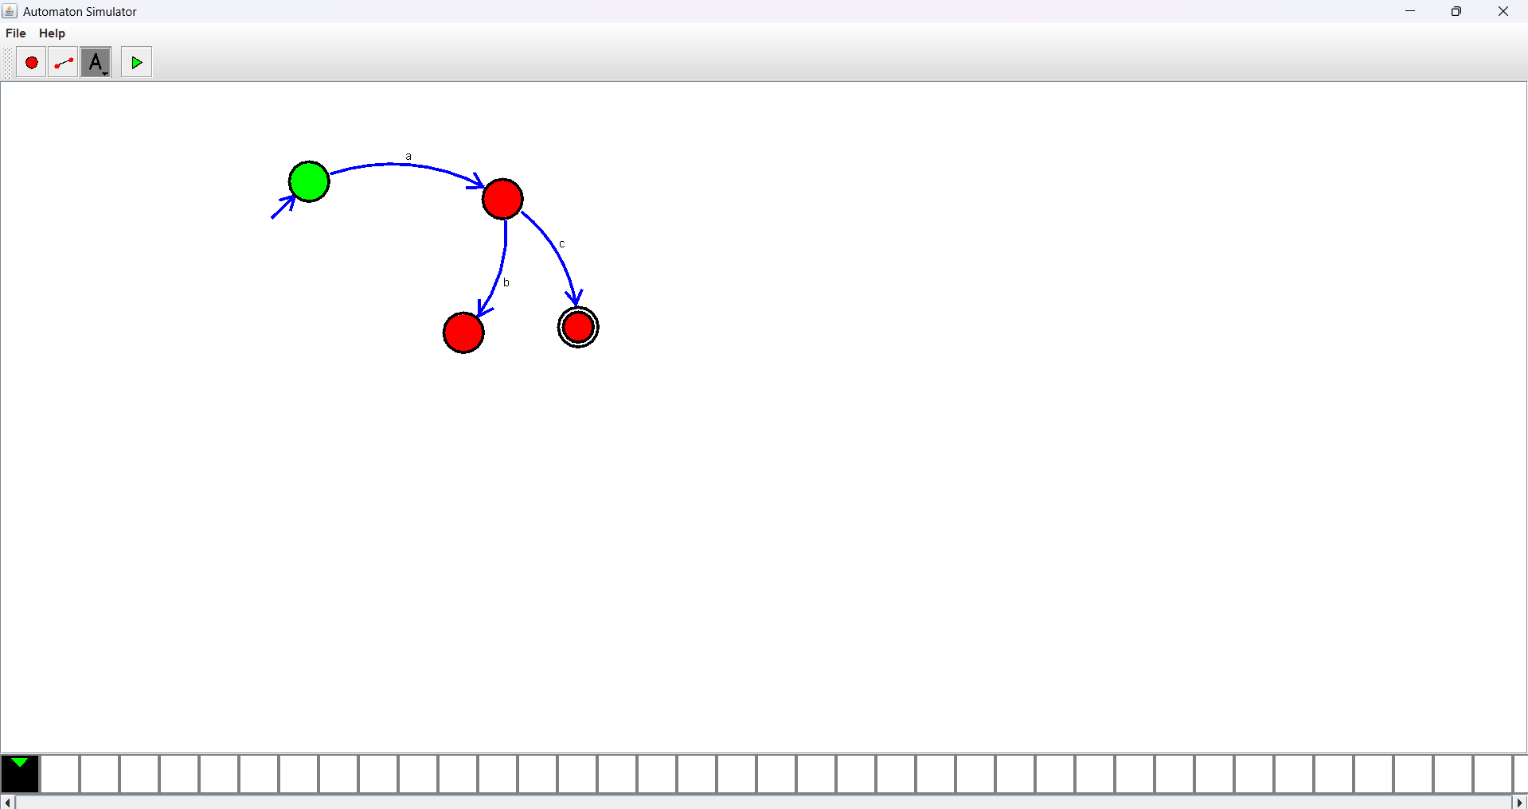

ε-NFA Diagram:
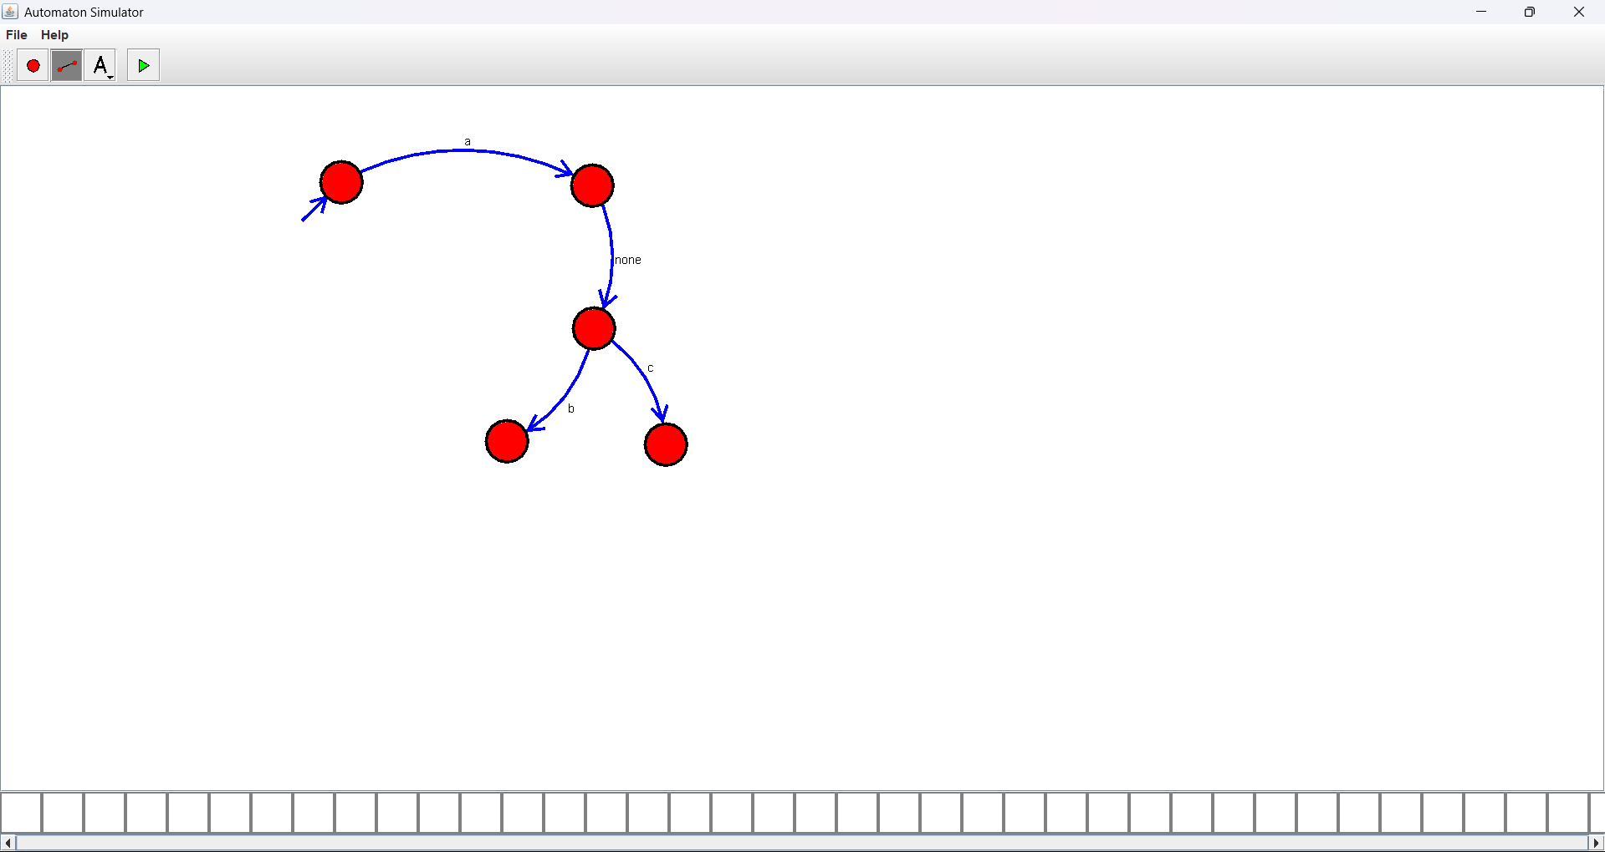

2.Given a DFA used for validating a specific PIN pattern bbbc, bca ,c, ca, caaaaaa minimize the DFA and explain how state reduction improves performance and efficiency in embedded systems

Minimized DFA Diagram:
